Credit Card Fraud Detection

***Wireframe Documentation***

**Homepage**

We have divided credit card fraud detection System’s Homepage into Two Sections: -

1. First thing anyone will see is a pop-up window on the Homepage which will ask for User Inputs.
   1. Click on this URL <https://creditcard-fraud-transaction.herokuapp.com/>

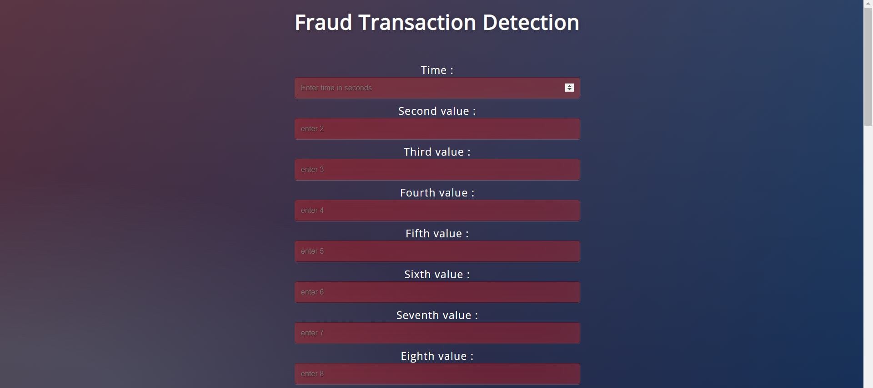

* 1. The User will encounter another pop-up window print out the transaction is Fraud or not.

